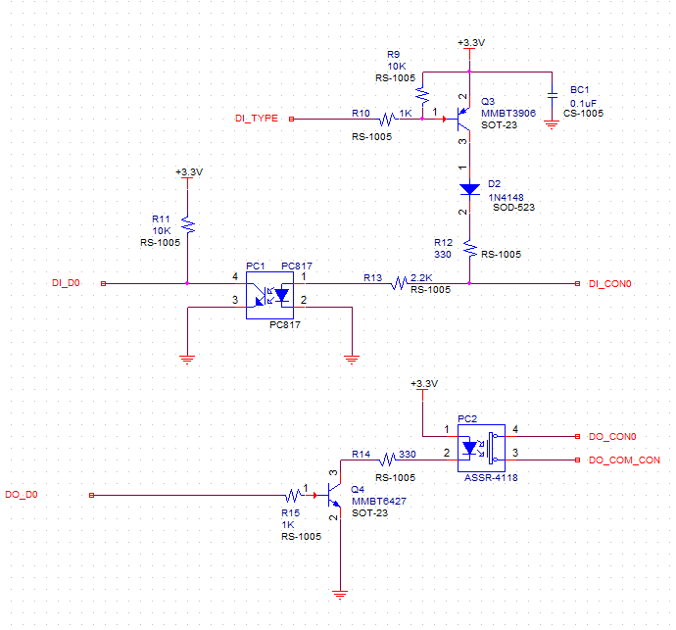

4 Pin Connector

1: DI_CON0

2: GND

3: DO_CON0

4: DO_COM_CON